WEB DEVELOPMENT PRACTICAL 1 AND 2 OUTPUT SCREEN SHOTS
- INDEX PAGE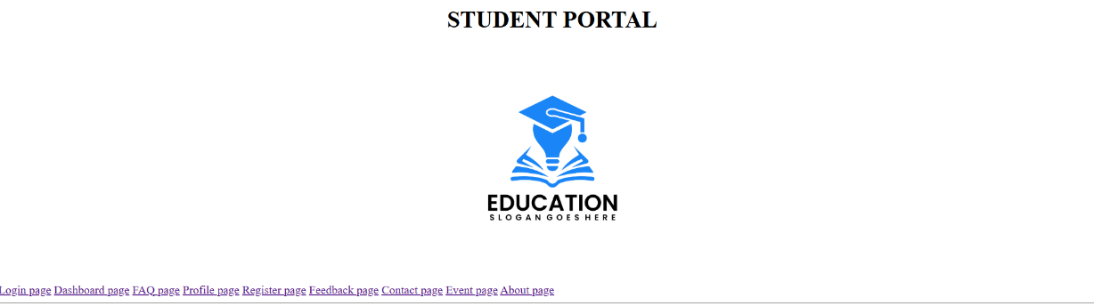
- REGISTER PAGE
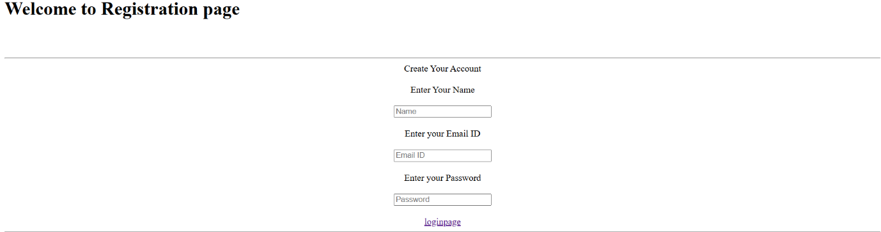
- LOGIN PAGE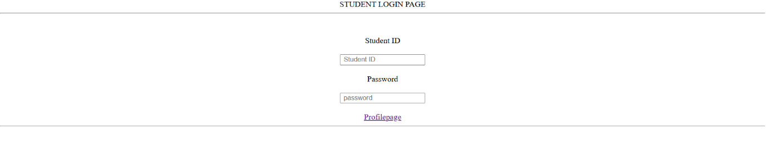
- PROFILE PAGE
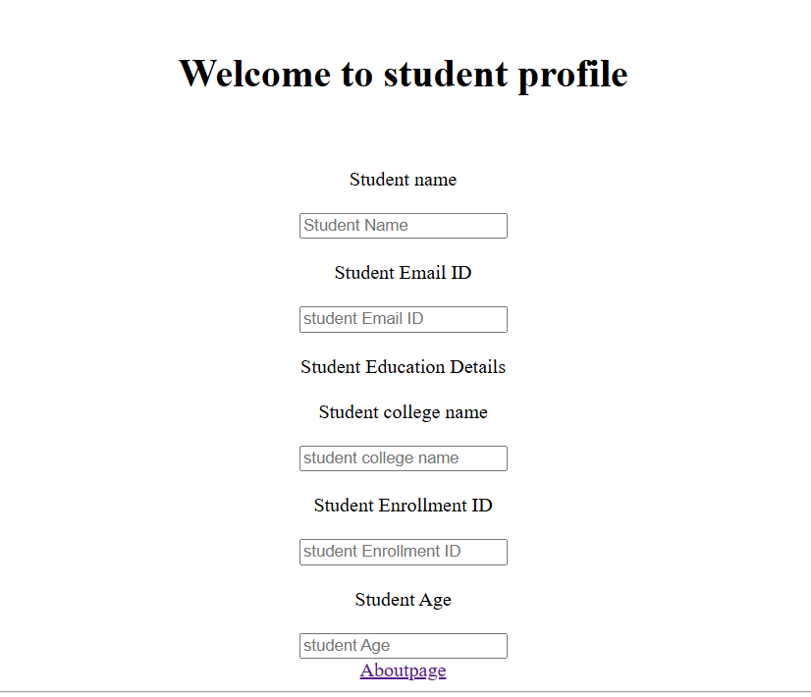
- ABOUT PROJECT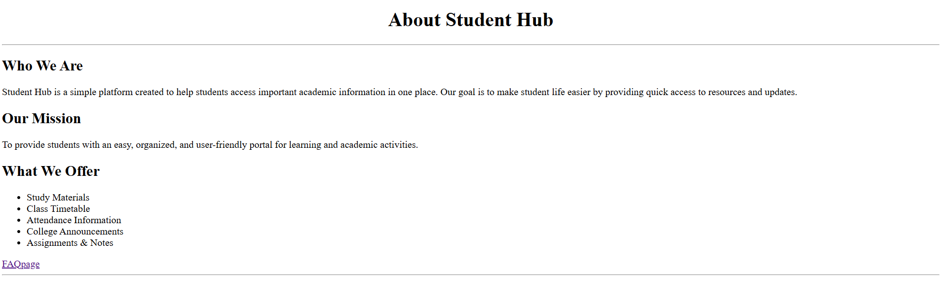
- FREEQUENTLY ASKED QUESTION
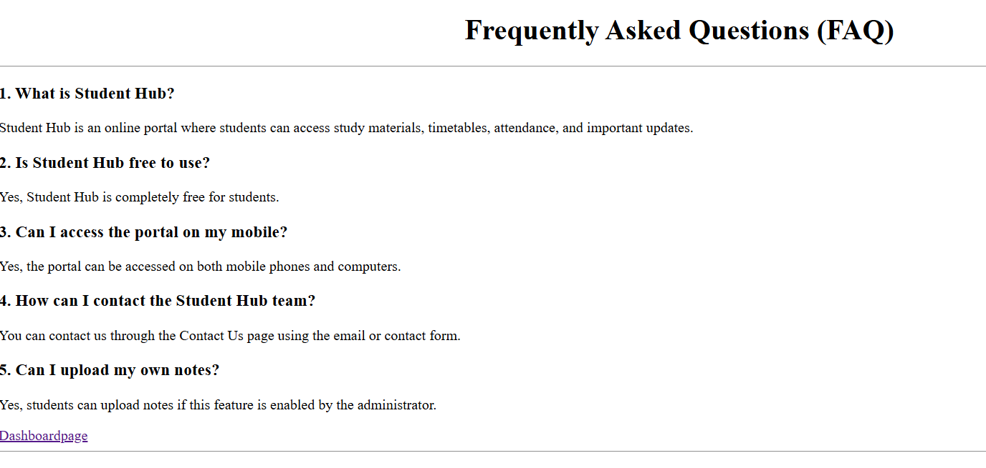
- DASHBOARD PAGE
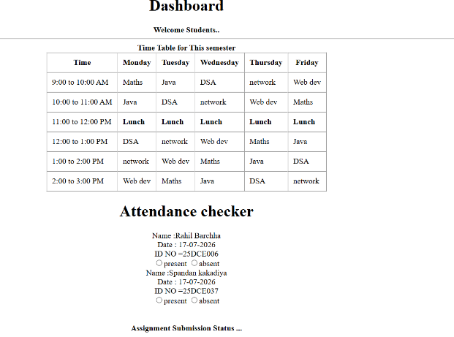
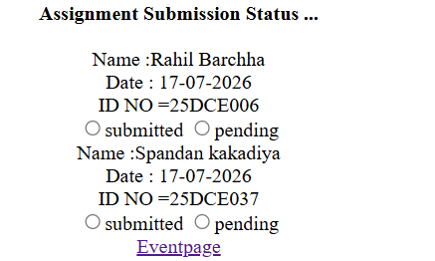
- EVENT REGISTRATION
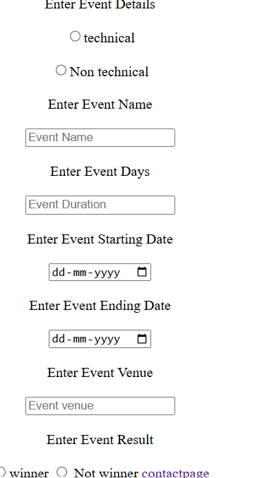

- CONTACT PAGE
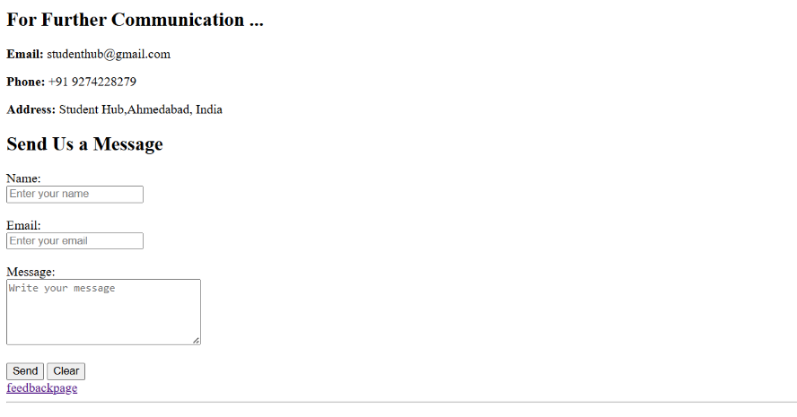
- FEEDBACK PAGE
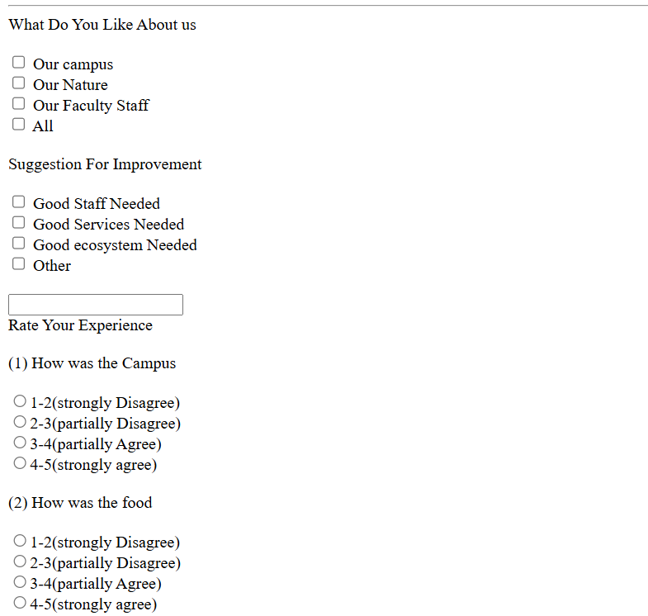
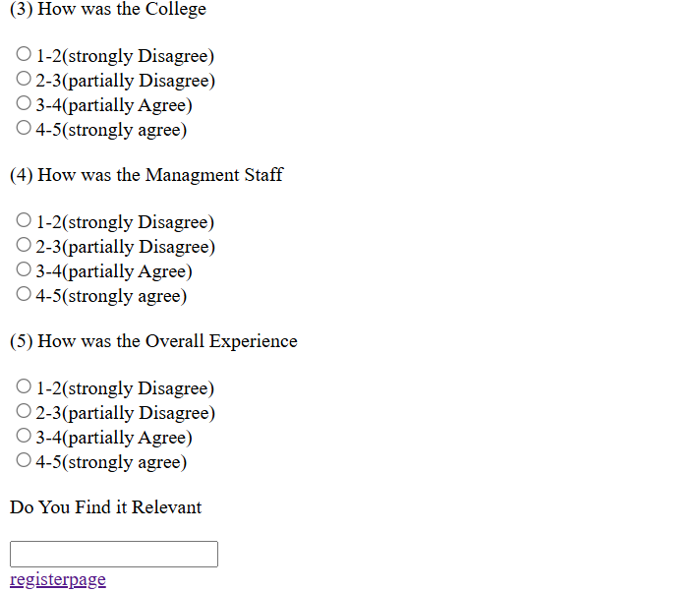
LEARNING OUTCOME :
PRACTICAL 1: Successfully analyzed the StudentHub project requirements and created a structured foundation by preparing the sitemap, wireframes, project folder structure, README, and GitHub repository. This practical improved understanding of project planning, navigation flow, and version control.
PRACTICAL 2:
Successfully developed semantic and accessible HTML5 pages for the StudentHub portal with proper page linking and consistent structure. This practical enhanced knowledge of semantic HTML, accessibility principles, and creating well-organized static web pages.

